**Leader Overview**

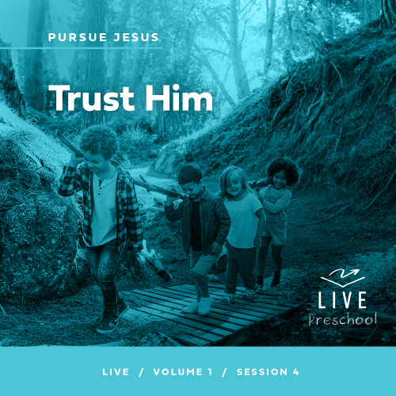

**Volume Overview**

**Pursue Jesus**

*Jesus’ offer is remarkably clear: If we look for Jesus, we’ll find Him. He’s not hiding from us, but closely connecting with Him does take us being intentional. We’re called to follow Him, to pursue Him. In this volume, we’ll look at how individuals pursued Jesus through the challenges of their circumstances. Pursuing Jesus is not only a mental exercise for personal growth, but it also means living out our faith in tangible ways: showing up, listening carefully, receiving grace, and trusting Him.*

**Session Overview**

**Trust Him**

*In this* **Live** *session, preschoolers will learn that they can trust Jesus. In the Bible story, Peter started out brave when he walked on the water toward Jesus. Then, he looked at the storm around them and started to sink. Like Peter, we all have times when we feel as if we are being tossed in a storm. Jesus comes close to us in those moments. We can call out to Jesus when we need help, and we can trust Him to help us when we’re afraid.*

**Bible Lesson**

Peter Walks toward Jesus on the Water

[Matthew 14:22–33](https://ref.ly/logosref/Bible.Mt14.22-33)

**Faith Fact**

I can trust Jesus if I’m afraid.

**Faith Verse**

[Jeremiah 29:13](https://ref.ly/logosref/Bible.Je29.13) (NLT)

“If you look for me wholeheartedly, you will find me.”

**Preparing for the Session**

**Leader Preparation Time: 20–25 Minutes**

|  |
| --- |
| ***You Will Need***  ***Preservice Activities***  *• Toys*  *• Bucket or large bowl*  *• Objects that will either sink or float (Examples: unpeeled and peeled oranges, plastic spoon, cotton ball, table tennis ball, marshmallow, ball, toys, piece of paper, paper clip, etc.)*  *• Plastic tablecloth*  *• Towel*  *• Sugar cookies*  *• Chocolate frosting*  *• Gummy bears or animal crackers*  *• Plastic knives, one per kid*  *• Small plates, one per kid*  *• Napkins or wet wipes*  ***Large Group***  *• Bible*  *• Worship songs (Song suggestions: “Whoa, I Have Life” by Yancy and Little Praise Party; “Superhero” by Hillsong Kids; “What a Beautiful Name” Lyric Video by Hillsong Kids)*  *• For groups not using a phone or tablet only, add:*  *• Projector or TV*  *• Laptop*  *•* ***Faith Fact Sound*** *video (bell ringing)*  *•* ***Faith Fact Slide***  *•* ***Faith Verse Slide***  *•* ***Faith Verse Video***  *•* ***Bible Lesson Video A***  *•* ***Bible Lesson Video B***  ***Small Group***  *• Objects for an obstacle course (Examples: large blocks, soft toys, a chair, etc.)*  *• Painter’s tape*  *• Optional: Blindfold or bandanna*  *•* ***Small Group Activity Page****, one per kid*  *• Pencils or pens, one per kid*  *• Crayons or markers*  *• Swim ring, swim floaties, or a life jacket, one per team*  *• Smartphone or timer*  *• Glass bottle with smooth sides, one per group*  *• Water*  *• Liquid dish soap*  *• Optional: Glitter*  *• Optional: Blue food coloring*  *To access session content and videos from a computer, visit:* [***BibleEngagementProject.com/downloads***](https://bibleengagementproject.com/downloads) |
| ***Getting Ready***  ***Preservice Activities***  *• Set out toys and snacks.*  *• Fill up the bucket halfway with water.*  *• Cover the table with the tablecloth and towel and set the bucket in the middle.*  ***Large Group***  *• Download videos and slides if needed.*  *• Select worship song(s) and have them ready to play.*  ***Small Group***  *• Set up the obstacle course using the objects. Keep it safe and simple to prevent injury.*  *• Optional: Tape a path for kids to follow through the course.*  *• Print copies of the* ***Small Group Activity Page****, one per kid*  *• Fill the bottle about ¾ full of water.*  *• Watch this video if you are not familiar with this experiment:* [*https://www.youtube.com/watch?v=cU7jUx5Mvx0*](https://www.youtube.com/watch?v=cU7jUx5Mvx0)  ***First time leading* Live *for Preschool? Check out the*** [**Facilitator Guide**](https://0b769b0ed3569ef9d18b-f88d8272f61086866d50d048b43ef630.ssl.cf2.rackcdn.com/sites/biblengagementproject/Listen_Facilitator_Guide.pdf)***.*** |

**Preservice Activities**

*See what’s needed at the beginning of the session.*

**Bible Story Warm-Up**

Today, we’ll hear a Bible story about a man named Peter who tried to walk on water, Have you ever walked on water before? *(Group response)* Not me! Before we dive into our time together today, I have some objects here. Let’s test them to see if they will float or sink in the water. I’ll hold up each item and ask if you think it will sink or float. Then, we’ll see if we guessed right.

• *Allow one kid at a time to choose an object.*

• *Ask the kids to guess if it will sink or float. Optional: Let them move to one side of the bucket or the other based on their choice.*

• *Place each object in the water and then talk together about whether they guessed sink or float correctly.*

• *Ask these questions when you’re finished.*

Were you surprised at which things sank and which ones floated?

Which object surprised you the most?

When you get in the bathtub or swimming pool, do you sink or float?

I’m excited to find out exactly what happened in our Bible story when Peter stepped out of the boat onto the water.

**Snack**

**Buddies in a Boat**

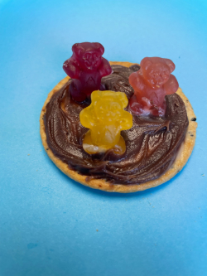

We have a fun snack today that goes with our Bible story. Jesus’ friends were together in a boat on a lake. Our snack will represent that.

First, let’s make the boat. Spread frosting on top of your cookie.

• *Hand out a plate with a cookie on it to each kid.*

• *Add frosting to a plastic knife and give one to each kid so they can place on the cookie. Help kids as needed.*

Finally, let’s add Jesus’ friends. Take your gummy bears and put their feet in the frosting so that it looks like they’re standing up.

• *Hand out gummy bears and assist as needed. Kids may need extra frosting behind the bears to get them to stand.*

Great job making your boat snacks. I can’t wait to find out what happened to Jesus’ friends when they were in a boat on the lake. Enjoy your snacks.

**Free Play**

*Any extra time can be spent playing with toys.*

**Transition**

*A few minutes before service begins have kids make their way to the large group area and sit in their designated areas.*

**Large Group**

**25 Minutes**

*See what’s needed at the beginning of the session.*

**Introduction**

Hi, kids! I’m so excited that you are here today. Point to yourself *(demonstrate)* and say, “That’s me.” *(Group response)* Yes, I’m so glad that each one of you is here. We’ll have fun learning from the Bible together today. *(Hold up the Bible.)* If you’re ready to explore a Bible story together, give me a thumbs-up. *(Group response)*

Today, we’re exploring a Bible story that has all kinds of exciting things in it—a storm, a boat tossed by huge waves, and Jesus doing a really amazing miracle. Do you want to hear what the miracle is or do you want to wait for the story? *(Group response)* You want to hear about it now? Are you sure? *(Group response)*

Okay, *(lean in close)* Jesus walked on water in our story. That’s incredible! You’ll have to listen to our story for that part. Jesus walked on the water toward His friends who were scared and needed help. They needed Jesus. Sometimes we need Jesus to help us, too. We can always trust Jesus to help us.

**Faith Fact**

Hey! That’s like our Faith Fact for today. **I can trust Jesus if I’m afraid.** You and I can trust Jesus all the time just like His disciples did.

• *Show the* ***Faith Fact Slide.***

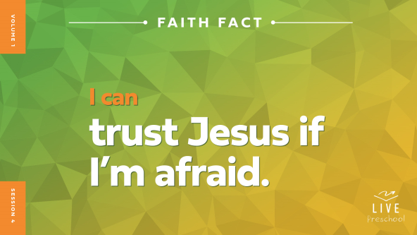

Let’s say our Faith Fact together. **I can trust Jesus if I’m afraid.** Let’s say it again with our bravest, strongest voice. **I can trust Jesus if I’m afraid.** Now, turn to the friend next to you and use your thumb to point to yourself *(demonstrate)* while we say it. **I can trust Jesus if I’m afraid.** Yes, you and I can trust Jesus.

**Bible Time**

We can learn to trust Jesus when we see how He helped people in the Bible. I wonder if Lizzy and Grandpa are going to share a special Bible story to help us learn about trusting Jesus. Let’s check in with them now.

• *Play* ***Bible Lesson Video A****.*

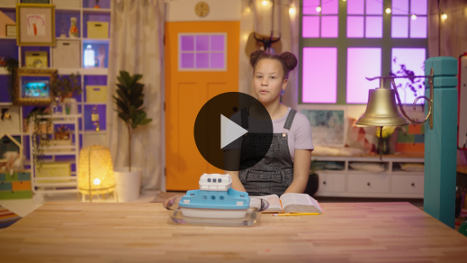

I’m so glad that Lizzy gave us a little time to think about our answer. Let’s spend some time in worshipping Jesus. Then, I’ll ask you what you think is going to happen next in our Bible story.

**Worship**

Jesus is so amazing, isn’t He? *(Group response)* Let’s tell Jesus how much we love Him.

**Praise**

Let’s thank Jesus for His great power! Make your strongest muscles and say, “Thank You, Jesus.” *(Group response)*

Are you thankful you can trust Jesus? Wave your hands up high. *(Group response)*

Who wants to show Jesus that you will trust Him? March in place like you’re following Jesus. *(Group response)*

**Sing**

Another way we worship Jesus is by singing. Let’s lift our voices together to worship Him.

*Lead the kids in singing one or two songs. See song suggestions at the beginning of the session.*

**Prayer**

Let’s talk to Jesus because He’s here with us. Everyone, bow your head and pray with me.

|  |
| --- |
| *Dear Jesus, You are so strong. You are so powerful. When we’re afraid, You are always there with us. Thank You that we can always trust You. Amen.* |

**Bible Time cont’d**

• *Start* ***Bible Lesson Video B*** *and pause on the image of the two choices.*

It’s almost time to check back in with Lizzy! Let’s think about what happens next in our Bible story. Put on your thinking caps *(demonstrate).* What do you think Peter did? Did he trust Jesus and step out on the water? *(Point to “foot” graphic.)* Or did he stay in the boat? *(Point to “boat” graphic.)*

If you think Peter stepped out onto the water, stand up and march in place *(demonstrate).* If you think Peter stayed in the boat, bend over and hug your knees like you’re sitting in the boat, and there’s a storm around you *(demonstrate).* Ready? Choose your answer.

*Pause while kids respond.*

Let’s find out if you’re right! Have a seat, and we’ll watch and listen to Lizzy.

• *Play* ***Bible Lesson Video B.***

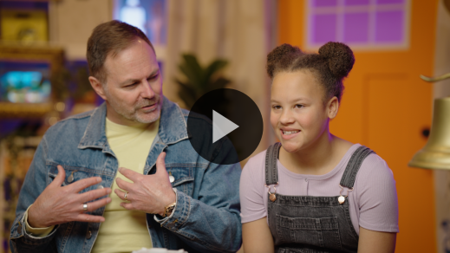

Wow, what a powerful Bible story! Let’s see if we can remember what happened. First, Jesus walked on water to help His friends who were scared. Then, Peter wanted to go to Jesus. What did Jesus say? *(Group response)* Yes! Jesus invited Peter to come to Him. Next, Peter walked out on the water. Did Peter stay on top of the water? *(Group response)* Poor Peter! He started to sink. Who did he call out to? *(Group response)* Jesus! Who can we always trust when we need help because we’re afraid? *(Group response)* You’re right! Jesus!

**Response Time**

*Play a worship song quietly.*

Let’s respond to what we’ve learned today. Hold your hands out like this *(open hands with palms up)*. This is how we hold our hands when someone is going to give us something. Today, we’ll trust Jesus to give us whatever kind of help we need.

Does anyone have something specific you need to trust Jesus with today? Maybe you feel scared about something like Peter and his friends. Remember, they were scared during the storm. Maybe someone close to you is sick. Maybe your family needs a new place to live. Maybe you sometimes have scary dreams. There are a lot of things we can be afraid of.

• *Optional: Let kids tell the group what they need to trust Jesus with.*

Like Peter in our Bible story, we can trust Jesus to help us when we’re afraid. Sometimes after we pray, we feel safe. That safe feeling is Jesus being close to us. Let’s pray together about what we’re facing.

• *Have the kids repeat phrases of the prayer after you.*

|  |
| --- |
| *Dear Jesus, You are so strong, and You are so full of love for each person here. You see what we need. We can trust You with everything. I pray that You pull us close so that we feel safe. We love You, Jesus. Amen.* |

**Faith Verse**

It can help us to trust Jesus when we have Bible verses that we can remember at any time. Let’s say our Faith Verse and do the actions together.

[Jeremiah 29:13](https://ref.ly/logosref/Bible.Je29.13) (NLT)

“If you look for me wholeheartedly, you will find me.”

• *Show the* ***Faith Verse Video****.*

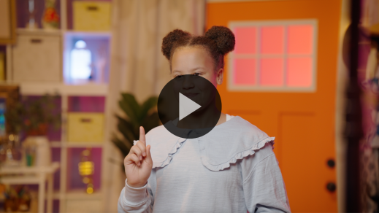

That was so great, friends! I love that we’re learning God’s Word when we’re together. This verse is a great one to say when we need Jesus to help us.

**Closing**

Let’s see *(thinking face).* Have we done everything for today? We’ve worshipped Jesus by singing and praying. We practiced our Faith Verse from the Bible. Did you learn more about trusting Jesus when you’re afraid? *(Group response)* What did you learn? *(Allow responses.)*

• *Play the* ***Faith Fact Sound*** *video (bell ringing).*

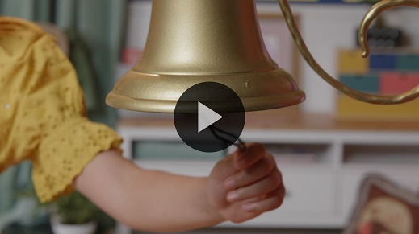

We learned our Faith Fact. Let’s say our Faith Fact one more time. **I can trust Jesus if I’m afraid.**

• *Show the* ***Faith Fact Slide.***



Let’s shout it together. Ready? **I can trust Jesus if I’m afraid.**

Now, let’s pretend we’re Peter sinking into the water. Do this with me. *(Demonstrate wobbling down to floor with arms flailing.)* Then, Jesus pulls us out while we say our Faith Fact one last time. *(Demonstrate jumping up with arms down by sides.)* **I can trust Jesus if I’m afraid.**

**Dismissal to Small Groups**

What a great time I’ve had with you, friends! Now, it’s time to do some small group activities. Let’s go!

• *Dismiss the kids by groups.*

|  |
| --- |
| ***Leader Tip:*** *This can be done by assigning color teams or by age groups. Note that some young preschoolers may not know their age. Using a colored sticker, jersey, or wristband will help separate the kids and help identify their small groups.* |

**Small Group**

**25 Minutes**

*See supplies and prep instructions at beginning of session or in each activity below.*

|  |
| --- |
| ***Leader Tip:*** *Small groups can alternate to each circle, or all groups can do each activity at the same time. If you choose to alternate, you will need at least one leader per circle*. |

**Circle 1**

**Group Connection**

**Blind Trust Trail**

|  |
| --- |
| ***You Will Need***  *• Objects for an obstacle course. (Examples: large blocks, soft toys, a chair, etc.)*  *• Painter’s tape*  *• Optional: Blindfold or bandanna*  ***Getting Ready***  *• Set up the obstacle course using the objects. Keep it safe and simple to prevent injury.*  *• Optional: Tape a path for kids to follow through the course.* |

Who’s been afraid of something before? Raise your hand. *(Group response)* I’ve been afraid before. What does our Faith Fact tell us about being afraid? Say it with me. **I can trust Jesus if I’m afraid.** We can always trust Jesus when we’re afraid. He is always with us even when we can’t see Him.

In this game, we’ll practice trusting. Can you see the path on the floor with objects around it? *(Group response)* You’ll close your eyes and trust a friend to help you follow the path on the floor without touching the objects along the way.

• *Assign partners or choose to lead each kid yourself.*

• *Optional: Let kids wear a blindfold if they’re comfortable doing so.*

• *Let the pairs walk the trail with one leading and one with closed eyes. Then, let the kids switch roles.*

• *During the activity, interrupt and practice the Faith Fact:* **I can trust Jesus if I’m afraid.**

• *Play the* ***Faith Fact Sound*** *video****.*** *Review the Faith Fact even if you can’t play the sound.*



How did it feel when you couldn’t see and had to trust your friend to tell you where to go? *(Allow responses.)* Did you ever feel afraid enough that you peeked? *(Allow responses.)*

Even Peter was afraid in our Bible story, and he was a grown-up man. He learned to trust Jesus when he was afraid. We can trust Jesus if we’re afraid, too. We all have things that we’re scared of. Even if we experience those things, Jesus is always with us. We can trust in Him.

**Circle 2**

**Activity Page Time**

**Fears or Faith?**

|  |
| --- |
| ***You Will Need***  *•* ***Small Group Activity Page****, one per kid*  *• Pencils or pens, one per kid*  *• Crayons or markers*  ***Getting Ready***  *• Print copies of the* ***Small Group Activity Page****, one per kid.* |

Today, we learned that we can trust Jesus even if we’re afraid.

• *Hand out a copy of the* ***Small Group Activity Page*** *and a pencil to each kid****.***

In the middle of your page is the Faith Fact. Say it with me. **I can trust Jesus if I’m afraid.** All around the Faith Fact are things we might be afraid of. What do you see?

• *Point to each picture and have kids describe it. Affirm correct answers.*

Now, take your pencil and circle the things that you have been afraid of before. Then, color the pictures.

• *Give kids time to complete the* ***Activity Page****. Assist them as needed.*

This ***Activity Page*** is a great reminder for us to trust Jesus when we feel afraid. Would anyone like to share what they are most afraid of? *(Allow responses.)* Next time you feel afraid, remember our Faith Fact. Let’s say it together. **I can trust Jesus if I’m afraid.** No matter what we are facing, Jesus is with us.

**Circle 3**

**Feet-to-Floor Game Time**

**Water Ring Race**

|  |
| --- |
| ***You Will Need***  *• Swim ring, swim floaties, or a life jacket, one per team*  *• Smartphone or timer*  *No prep needed for this activity.* |

Let’s play a game. Our Bible story was about Peter walking on water toward Jesus. When Peter was afraid, he began to sink. We have some things here that people can use so they don’t sink into the water. Let’s use them for a race.

• *Point to the end spot across the room.*

Half the group will line up over there, and the other half will line up by me. The first person in the line is going to put on the swim float and swim walk across the room. When it’s your turn, you’ll walk fast and move your arms in circles like you’re swimming *(demonstrate motion)*.

When you get to the other side, you’ll hand the swim float to the next person in line. Every person will have a turn to quickly take the swim float to the next person on the team. We’ll work together to see how fast we can go.

• *Divide the group into teams, positioning a team at each end of the race path.*

• *Start the timer and let kids race.*

Wow! You are awesome at swim walking! Great job, everyone!

• *Optional: Let kids play again and try to beat their time.*

These swim floats might have helped Peter when he was sinking, but instead he learned to call on and trust Jesus when he was afraid. We can do that, too. We can trust in Jesus if we’re afraid.

**Circle 4**

**Hands-On Learning**

**Storm in a Bottle Object Lesson**

|  |
| --- |
| ***You Will Need***  *• Glass bottle with smooth sides, one per group*  *• Water*  *• Liquid dish soap*  *• Optional: Glitter*  *• Optional: Blue food coloring*  ***Getting Ready***  *• Fill the bottle about ¾ full of water.*  *• Watch this video if you are not familiar with this experiment:* [*https://www.youtube.com/watch?v=cU7jUx5Mvx0*](https://www.youtube.com/watch?v=cU7jUx5Mvx0) |

Our story today was how Peter walked on water toward Jesus. Do you remember what was happening before Jesus got there and Peter stepped out of the boat? *(Allow responses.)* That’s right. There was a storm. Peter and the other disciples were scared of the storm.

Today, we’ll make a storm in a bottle. We’ll see what kind of storm we can create when we add some ingredients to this jar. I’ll add the things we need into the water.

• *Add a few drops of liquid soap to the glass bottle of water.*

• *Optional: Add a few pinches of glitter and a few drops of food coloring.*

We’re ready! Now, I’ll put the lid on. Then, I’ll turn the bottle upside down and spin it really fast.

• *Put the lid on tightly. Turn the bottle upside down and hold it on the top and bottom.*

• *Quickly spin the bottle in a circular motion to the right or left, like you’re trying to stir the water.*

• *Then pause the motion and watch the water spin into a mini tornado.*

Do you see the storm in the middle of the water? *(Group response)*. I’m sure I would be scared like Peter was if I were in a boat in the middle of the storm like this. If you’d been there in the storm, would you have asked Jesus if you could get out of the boat like Peter did? *(Allow responses.)*

• *Share with the kids what you would do.*

Whether we’re like Peter and want to get out of the boat or like his friends who stayed in the boat, we can all trust in Jesus. When we’re in a storm or facing something else that’s scary, what does our Faith Fact say? **I can trust Jesus if I’m afraid.**

**Dismissal**

• *Play the* ***Faith Fact Sound*** *video (bell ringing)****.***



• *Show the* ***Faith Fact Slide.***



That sound reminds us of our Faith Fact. Before we go, let’s say it together one more time. **I can trust Jesus if I’m afraid.** Great job! I had a great time learning more about the Bible and how we can trust Jesus when we’re afraid. See you next time!

• *Send home the* ***Small Group Activity Page*** *with each kid.*

• *Remind parents that there are* ***Family Devotions*** *available on the app to do with their kid.*

• *Tell everyone the date and time for the next session.*

.